Dynamic ARP Inspection (DAI)

Dynamic ARP Inspection (DAI) Configuration

Inacio Andre

2024

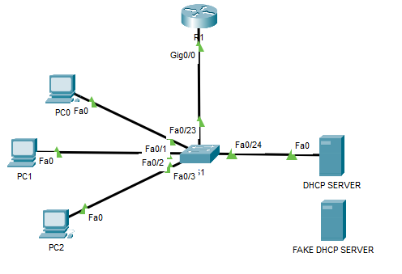

S1



